# GPS Analysis Project: Sample Runs

Ben Reynolds – 13309656

**Run 4.9km-----------------------------------------------------------------------------------------------------------**

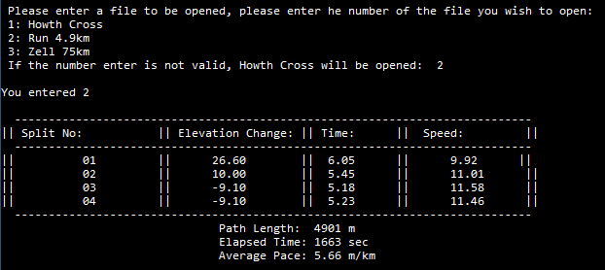

**Howth Cross:--------------------------------------------------------------------------------------------------------**

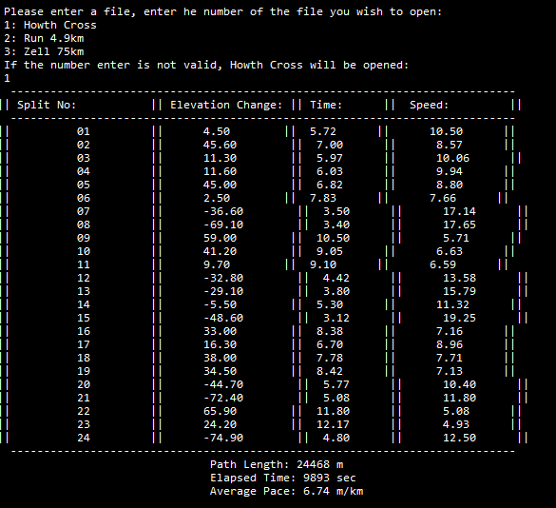

**Zell 75k ---------------------------------------------------------------------------------------------------------------**

